Develop a C program that uses the system calls open(), read(), write(), and close() to copy the contents of one file to another. Explain how control transitions between user space and kernel space during execution.

Code:

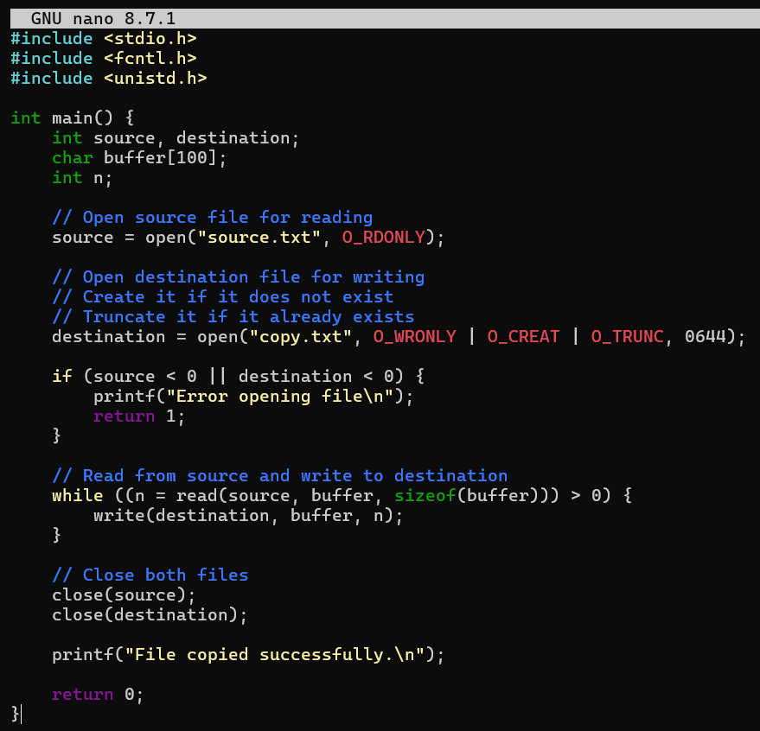

Output:
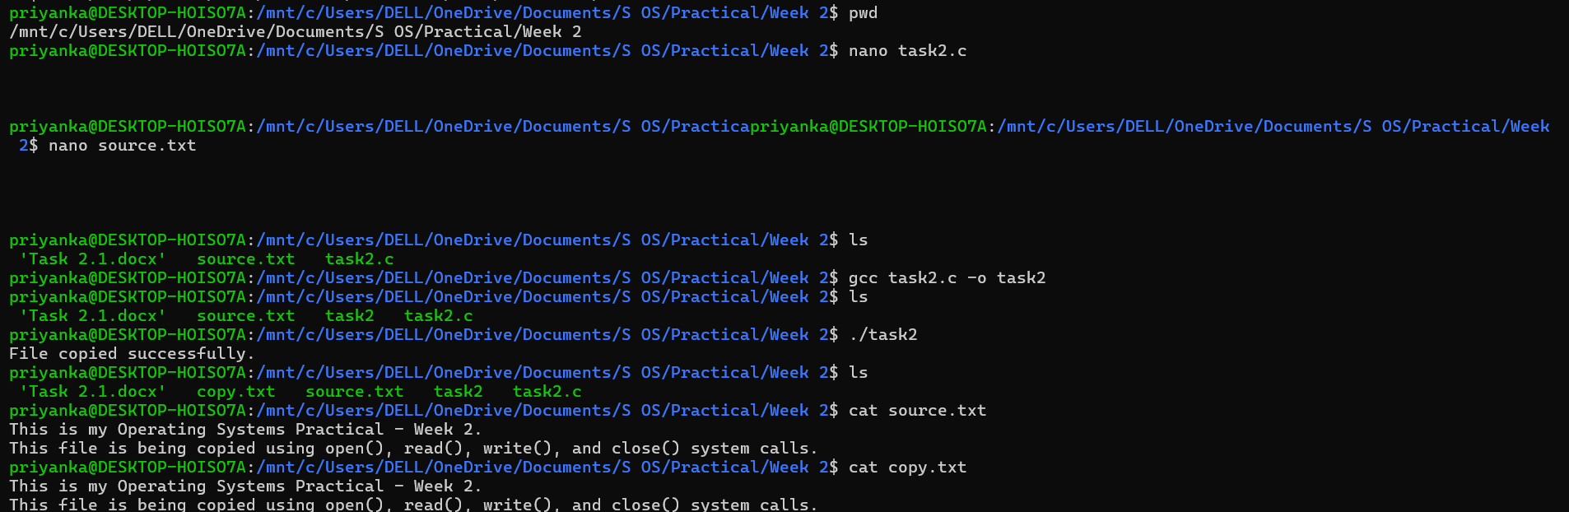

System calls provide an interface between user-space programs and kernel-space services. The open(), read(), write(), and close() calls allow the program to request file operations from the kernel.

